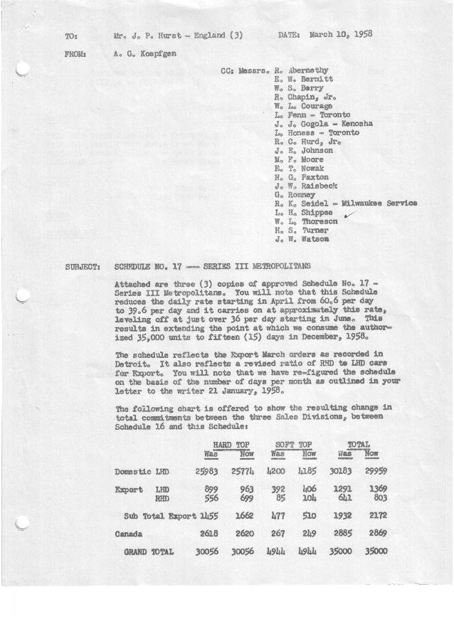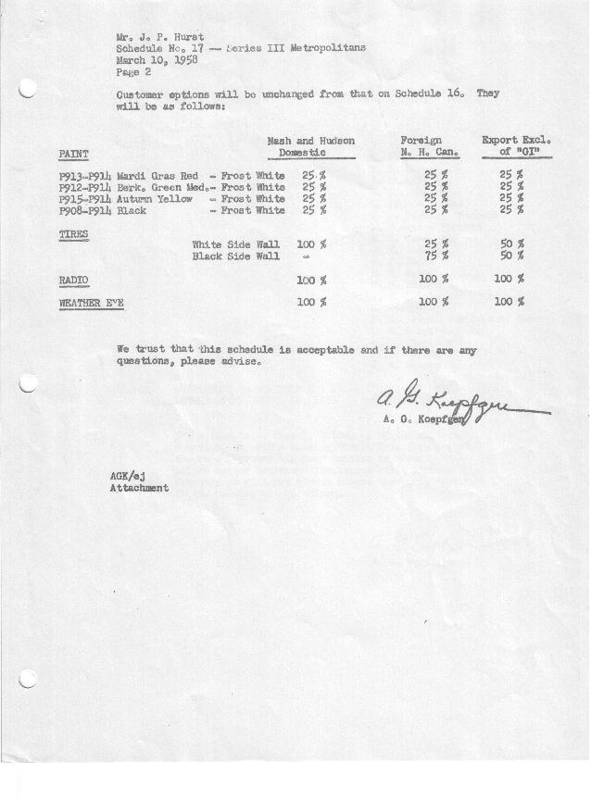

FORM AM 1262 Page 1 of 2 APPROVED R. Abernethy (signed) DATE 3-10-58

SCHEDULE NO. ______17 ___ DATE 3-7-58 MONTHLY BUILDING SCHEDULE APPROVED R. W.Chapin Jr. (signed) DATE_ 3/10/58
REVISION NO. _______ ______ DATE PRODUCT APPROVED E.W.Bernitt (signed) ___ _DATE _ 3-11-58 ____
SERIES III 1500 c.c. ENGINE
METROPOLITAN SERIES CARS – AUSTIN MOTORS CO., LTD, ENGLAND
DESCRIPTION | BUILT  ◻ACT EST  THRU  FEB | FIRM BUILDING SCHEDULE  (FABRICATED MATERIAL RELEASE) |  |  |  |  |  |  |  |  |  |  |  |  |  |  | TENTATIVE SCHEDULE  (RAW MATERIAL RELEASED) |  |  | GRAND  TOTAL
DESCRIPTION | BUILT  ◻ACT EST  THRU  FEB | MONTH March  DAYS 21 |  |  | MONTH April  DAYS 20 |  |  | MONTH May  DAYS 20 |  |  | MONTH June  DAYS 21 |  |  | MONTH July  DAYS 19 |  |  | MONTH August  DAYS 15 |  |  | GRAND  TOTAL
DESCRIPTION | BUILT  ◻ACT EST  THRU  FEB | DAILY | MONTH | CUM’L  TOTAL | DAILY | MONTH | CUM’L  TOTAL | DAILY | MONTH | CUM’L  TOTAL | DAILY | MONTH | CUM’L  TOTAL | DAILY | MONTH | CUM’L  TOTAL | DAILY | MONTH | CUM’L TOTAL | GRAND  TOTAL
DOMESTIC LHD:
Hard-Top | 20408 |  | 824 | 21232 |  | 490 | 21722 |  | 483 | 22205 |  | 509 | 22714 |  | 502 | 23216 |  | 396 | 23612
Soft-Top | 3251 |  | 216 | 3467 |  | 110 | 3577 |  | 117 | 3694 |  | 121 | 3815 |  | 68 | 3883 |  | 54 | 3937
Total U.S. | 23659 | 49.5 | 1040 | 24699 | 30.0 | 600 | 25299 | 30.0 | 600 | 25899 | 30.0 | 630 | 26529 | 30.0 | 570 | 27099 | 30.0 | 450 | 27549
Over/(Under) Schedule 16 | (32) |  | 32 | -0- |  | (360) | (360) |  | (456) | (816) |  | (282) | (1098) |  | (102) | (1200) |  | (510) | (1710)
FOREIGN:
EXPORT LHD Hard-Top | 692 |  | 17 | 709 |  | 30 | 739 |  | 22 | 761 |  | 22 | 783 |  | 22 | 805 |  | 22 | 827
Soft-Top | 318 |  | 12 | 330 |  | 10 | 340 |  | 8 | 348 |  | 8 | 356 |  | 8 | 364 |  | 4 | 368
Total Export LHD | 1010 |  | 29 | 1039 |  | 40 | 1079 |  | 30 | 1109 |  | 30 | 1139 |  | 30 | 1169 |  | 26 | 1195
RHD Hard Top | 327 |  | 45 | 372 |  | 35 | 407 |  | 35 | 442 |  | 35 | 477 |  | 28 | 505 |  | 20 | 525
Soft Top | 56 |  | 5 | 61 |  | 5 | 66 |  | 5 | 71 |  | 5 | 76 |  | 4 | 80 |  | -0- | 80
Total Export RHD | 383 |  | 50 | 433 |  | 40 | 473 |  | 40 | 513 |  | 40 | 553 |  | 32 | 585 |  | 20 | 605
Total Export LHD & RHD | 1393 | 3.8 | 79 | 1472 | 4.0 | 80 | 1552 | 3.5 | 70 | 1622 | 3.3 | 70 | 1692 | 3.3 | 62 | 1754 | 3.1 | 46 | 1800
Over/(Under) Schedule 16 | -0- |  | -0- | -0- |  | -0- | -0- |  | -0- | -0- |  | -0- | -0- |  | (18) | (18) |  | (34) | (52)
CANADA Hard-Top | 2015 |  | 150 | 2165 |  | 89 | 2254 |  | 84 | 2338 |  | 52 | 2390 |  | 54 | 2444 |  | 51 | 2495
Soft-Top | 173 |  | 16 | 189 |  | 22 | 211 |  | 20 | 231 |  | 9 | 240 |  | 9 | 249 |  | -0- | 249
Total Canada | 2188 | 7.9 | 166 | 2354 | 5.6 | 111 | 2465 | 5.2 | 104 | 2569 | 2.9 | 61 | 2630 | 3.3 | 63 | 2693 | 3.4 | 51 | 2744
Over/(Under) Schedule 16 | 32 |  | (32) | -0- |  | (60) | (60) |  | (56) | (116) |  | (4) | (120) |  | 3 | (117) |  | 1 | (116)
Total Foreign | 3581 | 11.7 | 245 | 3826 | 9.6 | 191 | 4017 | 8.7 | 174 | 4191 | 6.2 | 131 | 4322 | 6.6 | 125 | 4447 | 6.5 | 97 | 4544
Over/(Under) Schedule 16 | 32 |  | (32) | -0- |  | (60) | (60) |  | (56) | (116) |  | (4) | (120) |  | (15) | (135) |  | (33) | (168)
GRAND TOTALS
Hard-Top | 23442 | 49.3 | 1036 | 24478 | 32.2 | 644 | 25122 | 31.2 | 624 | 25746 | 29.4 | 618 | 26364 | 31.9 | 606 | 26970 | 32.6 | 489 | 27459
Soft-Top | 3798 | 11.9 | 249 | 4047 | 7.4 | 147 | 4194 | 7.5 | 150 | 4344 | 6.8 | 143 | 4487 | 4.7 | 89 | 4576 | 3.9 | 58 | 4634
Total | 27240 | 61.2 | 1285 | 28525 | 39.6 | 791 | 29316 | 38.7 | 774 | 30090 | 36.2 | 761 | 30851 | 36.6 | 695 | 31546 | 36.5 | 547 | 32093
Over/(Under) Schedule 16 | -0- |  | -0- | -0- |  | (420) | (420) |  | (512) | (932) |  | (286) | (1218) |  | (117) | (1335) |  | (543) | (1878)

FORM AM 1262 Page 2 of 2 APPROVED R. Abernethy (signed) DATE 3-10-58

SCHEDULE NO. ______17 ___ DATE 3-7-58 MONTHLY BUILDING SCHEDULE APPROVED R. W.Chapin Jr. (signed) DATE_ 3/10/58 _
REVISION NO. _______ ______ DATE PRODUCT APPROVED E.W.Bernitt (signed) ___ _DATE _ 3-11-58 ____
SERIES III 1500 c.c. ENGINE
METROPOLITAN SERIES CARS – AUSTIN MOTORS CO., LTD, ENGLAND
DESCRIPTION | BUILT  ◻ACT◻ EST  THRU | FIRM BUILDING SCHEDULE  (FABRICATED MATERIAL RELEASE) |  |  |  |  |  |  |  |  |  |  |  |  |  |  | TENTATIVE SCHEDULE  (RAW MATERIAL RELEASED) |  |  | GRAND  TOTAL
DESCRIPTION | BUILT  ◻ACT◻ EST  THRU | MONTH September  DAYS 22 |  |  | MONTH October  DAYS 23 |  |  | MONTH November  DAYS 20 |  |  | MONTH December  DAYS 15 (21 Available) |  |  | MONTH  DAYS |  |  |  |  |  | GRAND  TOTAL
DESCRIPTION | BUILT  ◻ACT◻ EST  THRU | DAILY | MONTH | CUM’L  TOTAL | DAILY | MONTH | CUM’L  TOTAL | DAILY | MONTH | CUM’L  TOTAL | DAILY | MONTH | CUM’L  TOTAL | DAILY | MONTH | CUM’L  TOTAL | DAILY | MONTH | CUM’L TOTAL | GRAND  TOTAL
DOMESTIC LHD:
Hard-Top |  |  | 587 | 24199 |  | 621 | 24820 |  | 540 | 25360 |  | 414 | 25774
Soft-Top |  |  | 73 | 4010 |  | 69 | 4079 |  | 60 | 4139 |  | 46 | 4185
Total U.S. |  | 30.0 | 660 | 28209 | 30.0 | 690 | 28899 | 30.0 | 600 | 29499 | 31.1 | 460 | 29959
Over/(Under) Schedule 16 |  |  | (264) | (1974) |  | 690 | (1284) |  | 600 | (684) |  | 460 | (224)
FOREIGN:
EXPORT LHD Hard-Top |  |  | 40 | 867 |  | 36 | 903 |  | 30 | 933 |  | 30 | 963
Soft-Top |  |  | 10 | 378 |  | 8 | 386 |  | 10 | 396 |  | 10 | 406
Total Export LHD |  |  | 50 | 1245 |  | 44 | 1289 |  | 40 | 1329 |  | 40 | 1369
RHD Hard Top |  |  | 58 | 583 |  | 46 | 629 |  | 35 | 664 |  | 35 | 699
Soft Top |  |  | 8 | 88 |  | 8 | 96 |  | 3 | 99 |  | 5 | 104
Total Export RHD |  |  | 66 | 671 |  | 54 | 725 |  | 38 | 763 |  | 40 | 803
Total Export LHD & RHD |  | 5.3 | 116 | 1916 | 4.3 | 98 | 2014 | 3.9 | 78 | 2092 | 5.4 | 80 | 2172
Over/(Under) Schedule 16 |  |  | 36 | (16) |  | 98 | 82 |  | 78 | 160 |  | 80 | 240
CANADA Hard-Top |  |  | 25 | 2520 |  | 50 | 2570 |  | 50 | 2620 |  | -0- | 2620
Soft-Top |  |  | -0- | 249 |  | -0- | 249 |  | -0- | 249 |  | -0- | 249
Total Canada |  | 1.1 | 25 | 2769 | 2.1 | 50 | 2819 | 2.5 | 50 | 2869 | -0- | -0- | 2869
Over/(Under) Schedule 16 |  |  | -0- | (116) |  | 50 | (66) |  | 50 | (16) |  | -0- | (16)
Total Foreign |  | 6.4 | 141 | 4685 | 6.4 | 148 | 4833 | 6.4 | 128 | 4961 | 5.4 | 80 | 5041
Over/(Under) Schedule 16 |  |  | 36 | (132) |  | 148 | 16 |  | 128 | 144 |  | 80 | 224
GRAND TOTALS
Hard-Top |  | 32.3 | 710 | 28169 | 32.7 | 753 | 28922 | 32.7 | 655 | 29577 | 32.3 | 479 | 30056
Soft-Top |  | 4.1 | 91 | 4725 | 3.7 | 85 | 4810 | 3.7 | 73 | 4883 | 4.1 | 61 | 4944
Total |  | 36.4 | 801 | 32894 | 36.4 | 838 | 33732 | 36.4 | 728 | 34460 | 36.4 | 540 | 35000
Over/(Under) Schedule 16 |  |  | (228) | (2106) |  | 838 | (1268) |  | 728 | (540) |  | 540 | -0-

